Admit Your Recruiting Strategy is Broken
& Do Something About It

Dr. Wade Larson, SHRM-SCP, SPHR
Optimal Talent Dynamics
SHRM Talent 2023

RECRUITMENT
 | ASSUMPTIONS | REALITIES
Pre-Pandemic
Post-Pandemic

OTHER REFLECTIONS:

BUILDING YOUR RECRUITMENT STRATEGY

 | ADOPT & IMPLEMENT BEST PRACTICES | Find what others do, adapt to meet your needs, continuously try new things.
 | RE-SKILL WORKERS | Continuous Improvement in Talent Development & Improvement
 | TAKE A WORKFORCE DEVELOPMENT APPROACH | Balance INTERNAL and EXTERNAL resources to meet needs (both short-term and long-term)
 | “RE-WORK” WORK | Take a different approach to how you get things done…
 | FOCUS ON ORGANIZATIONAL CULTURE FIRST | Create a sustainable culture where people want to come and stay…

- Focus on Organizational Culture First

Q: Why should anyone want to work for you?
(Current Employees ● Candidates ● Money Isn’t an Option)

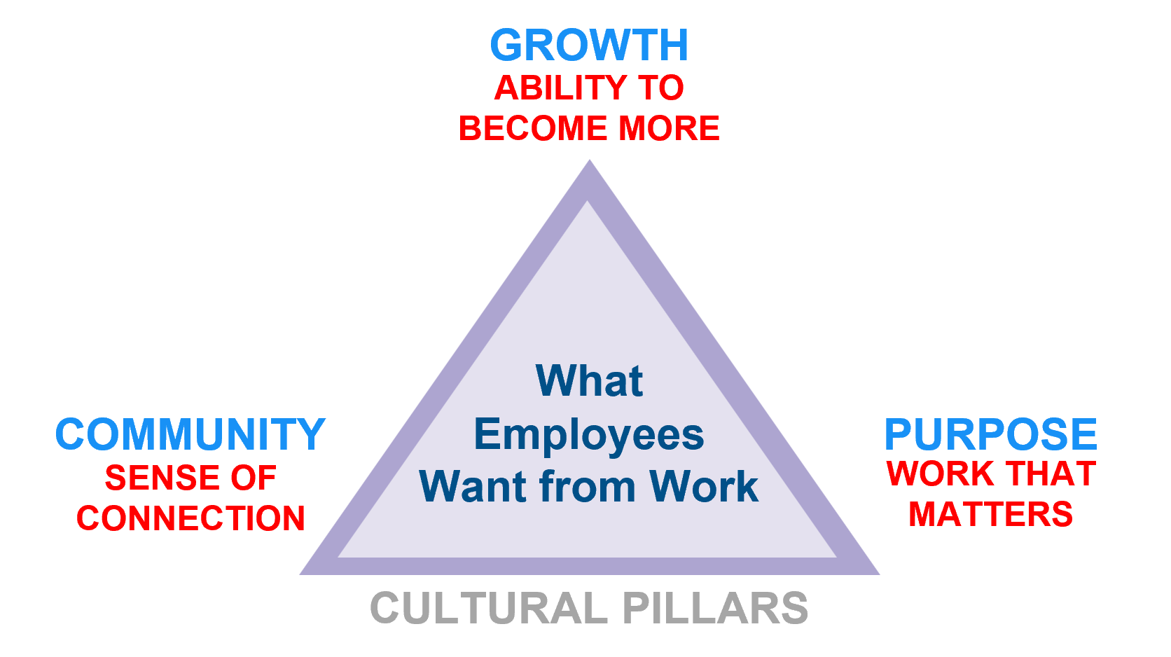
What are your cultural pillars?

- How do people grow?

- How does their work matter?

- How do you build community?

- Re-Work Work

Competencies

Eliminate – Automate – Delegate – Consolidate – Streamline/Re-Align

- Workforce Development

Succession Planning

IDPs

- Up-Skill/Re-Skill Talent

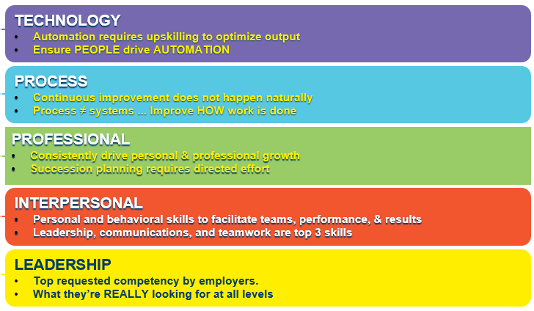

- Best Practices

